For use case/dfd/…

<https://app.diagrams.net/>

Diagram maker ai

<https://www.eraser.io/diagramgpt>

Team invite <https://app.eraser.io/invite/y150EcRBQQl45jHYxsDg>

**Flow Chart**

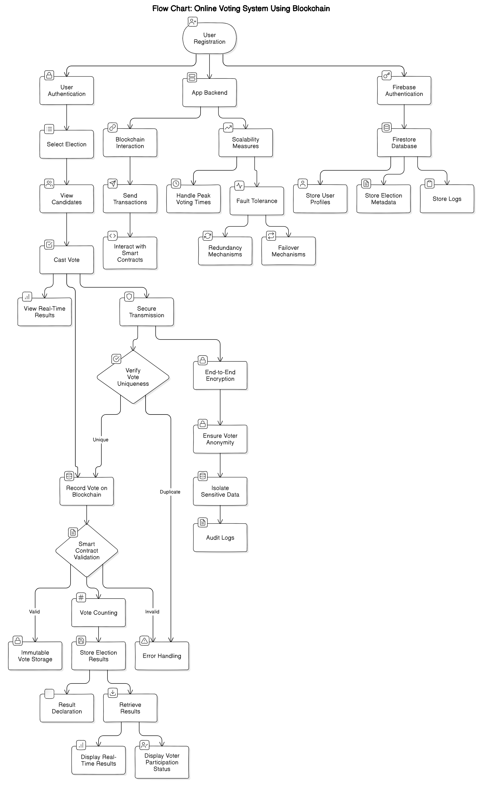

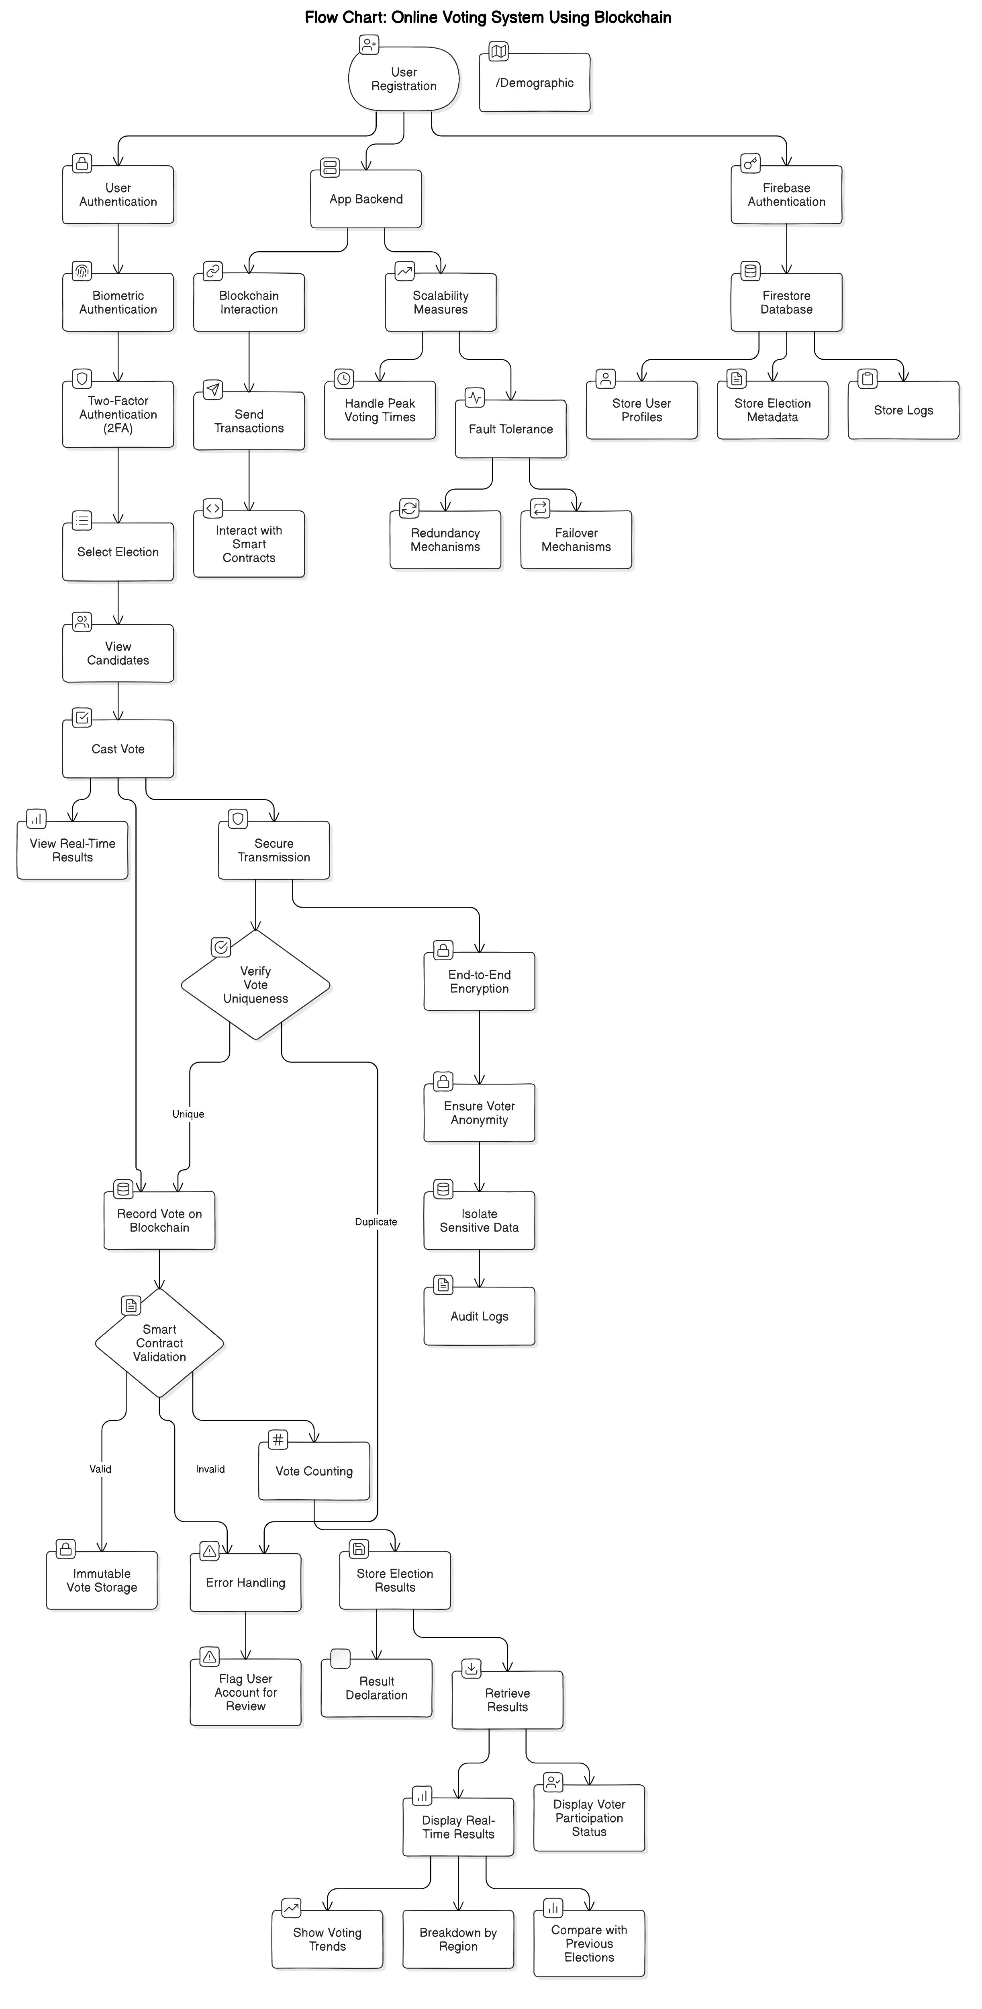

**Rough Architecture**

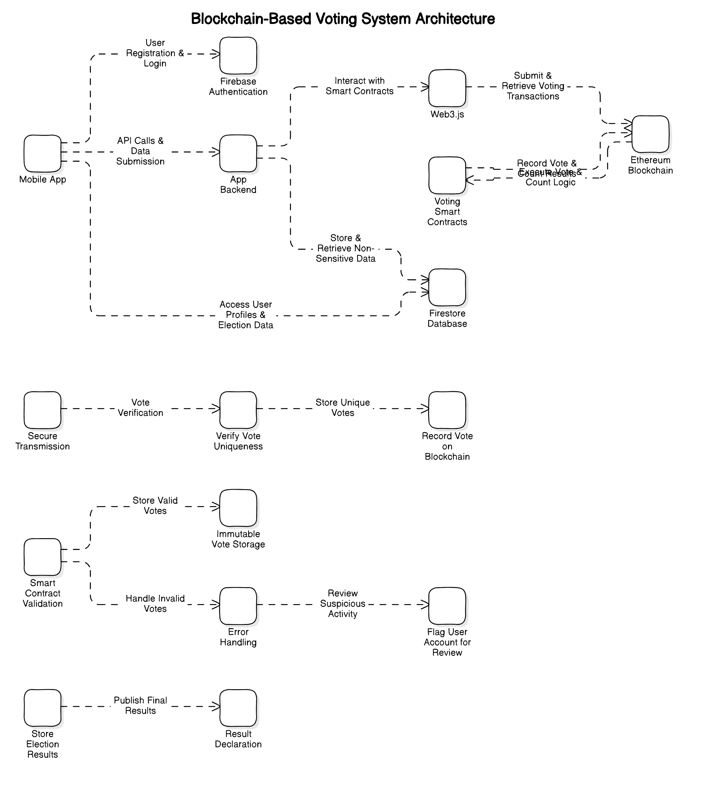

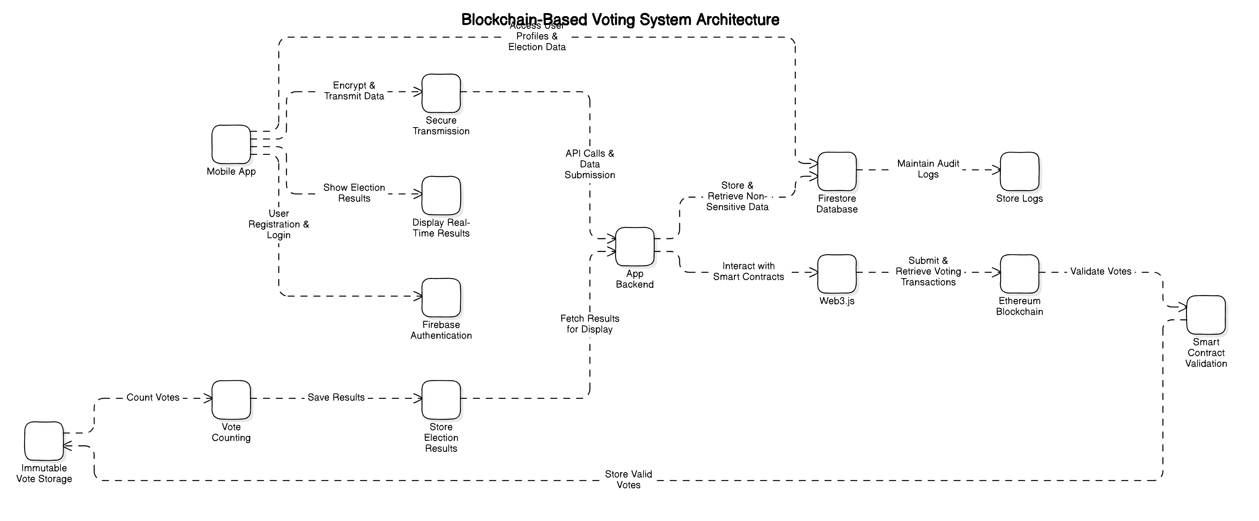

**Architecture**

